Building Verifiable Credential Ecosystems: A Practical Guide for Governments & Issuers
A practical, explanatory guide for governments or Issuers and digital identity architects to understand the major building blocks of a Verifiable Credentials (VC) ecosystem and make informed architectural decisions.

Introduction
Verifiable Credentials (VCs) are increasingly becoming the foundation for digital identity wallets, mobile driving licences, educational certificates, travel credentials, and citizen-centric data sharing ecosystems. However, governments embarking on this journey often encounter an overwhelming landscape of standards, protocols, and technologies—SD-JWT VC, W3C VCDM, ISO mdoc, OpenID4VCI, OpenID4VP, Trust Registries, OpenID Federation, and many more.
The natural question becomes: Where do we begin, and how do all these standards fit together?
The answer is that Verifiable Credentials are not a single technology or specification. They are an interoperable technology stack composed of five architectural layers. Every government designing a VC ecosystem must make decisions at each of these layers from how data is cryptographically protected, to how credentials are represented and structured, how they move between ecosystem participants, and ultimately how trust is established across wallets, issuers, and verifiers. Understanding these five layers provides a practical blueprint for designing digital credential ecosystems that are secure, interoperable, and future-ready.
Every Verifiable Credential ecosystem, whether it is a national identity wallet, a mobile driving licence, a university degree platform, or a cross-border digital identity system, can ultimately be understood through these five architectural decisions.

Decoding each layers within the VC
At first glance, these five layers may appear to be independent technology choices. In practical deployments, they build upon one another to form a complete Verifiable Credential ecosystem. A government cannot decide how credentials will be presented before determining how they are represented. Similarly, representation choices may influence data models, and data exchange cannot occur unless trust is first established between ecosystem participants.
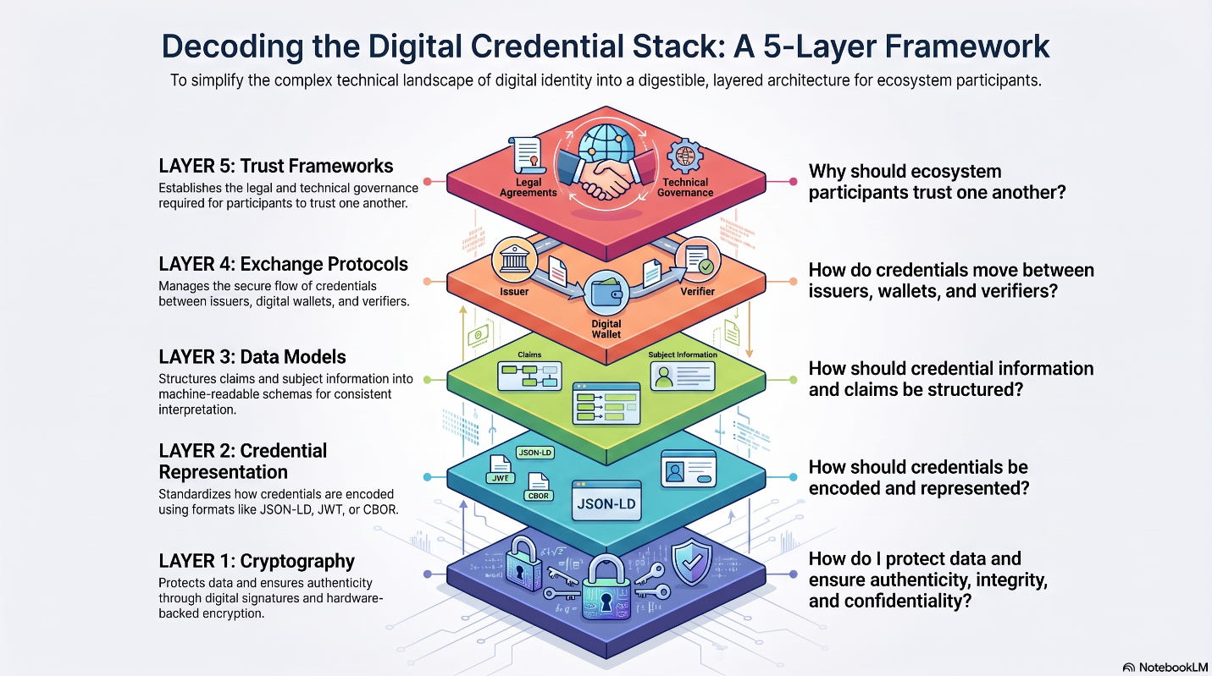
Figure 1: Five-Layer Architectural Stack of Verifiable Credentials
A useful way to think about these layers is as a sequence of architectural questions that every government must answer while designing a Verifiable Credential ecosystem. The journey begins with protecting the data through appropriate cryptographic mechanisms. Once the data is secured, the next decision is how credentials should be represented and encoded for storage and exchange. Governments must then determine how information within the credential should be structured, including claims, metadata, and relationships between different entities. After defining the credential itself, attention shifts to how credentials are issued to wallets and presented to relying parties. Finally, because credentials are exchanged between multiple independent participants, mechanisms must be established to ensure that issuers, wallets, and verifiers can trust one another before any data is shared. By answering these questions one by one, governments can progressively assemble a Verifiable Credential ecosystem that is secure, interoperable, and aligned with their policy objectives.

2.1 Layer 1: Cryptography – How Will You Protect Your Data?
Every digital credential ultimately represents trust in data. Before deciding how credentials look or move across ecosystems, governments must first determine how that data will be protected. Cryptography provides the foundation that ensures credentials cannot be forged, tampered with, or accessed by unauthorized parties. In practice, cryptography focuses on the essential security properties such as authenticity, data integrity, confidentiality, non-repudiation and quantum resilience.
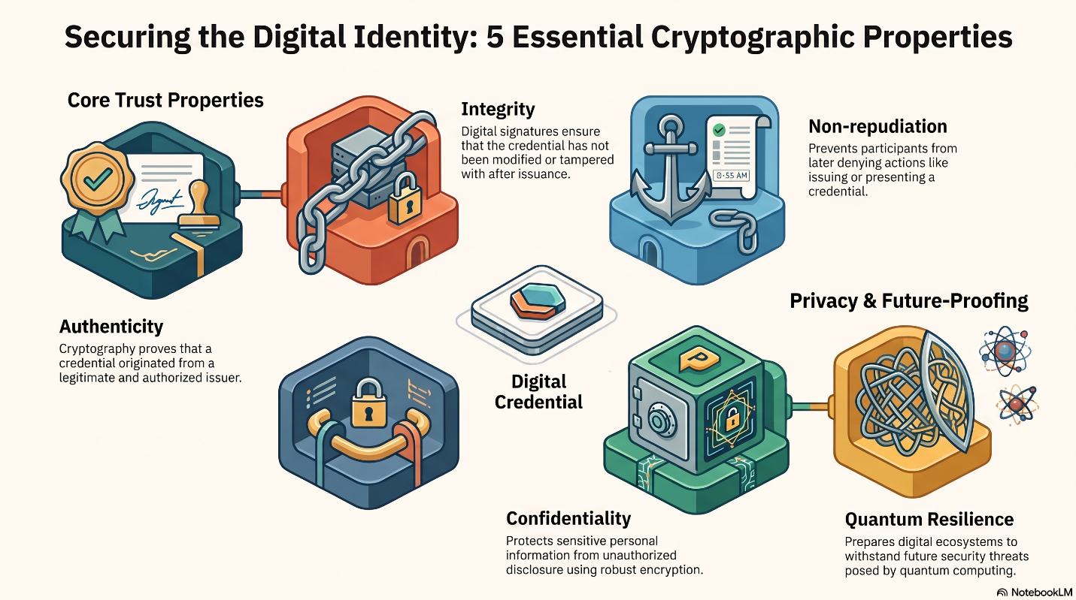
Issuers typically need to make cryptographic decisions across digital signatures, Encryption, Hashing and key exchange process. The table below represents the usual choices made by companies for cryptography.
Purpose | Current Standards | Emerging Standards
Digital Signatures | RSA, ECDSA, EdDSA | ML-DSA
Encryption | AES-GCM, ChaCha20-Poly1305 | AES with PQ key exchange
Key Exchange | ECDH | ML-KEM
Hashing | SHA-256, SHA-384 | SHA-3
Table 1: Cryptographic landscape
The choice of cryptographic algorithms should be guided by the ecosystem's existing infrastructure, deployment environment, and long-term security objectives. Countries with established PKI ecosystems may continue leveraging RSA or ECDSA, while mobile-first deployments often prefer ECDSA or EdDSA because of their smaller key sizes and computational efficiency. Systems that require long-term credential validity should begin preparing for a transition to post-quantum cryptography, and new implementations should evaluate emerging standards such as ML-KEM and ML-DSA to ensure future resilience against quantum computing threats.
Fortunately, cryptography is largely independent of the remaining layers of the Verifiable Credential stack. Issuers can progressively evolve their cryptographic algorithms over time, including migrating towards post-quantum cryptography, without fundamentally redesigning their credential representations, exchange protocols, or trust frameworks.

2.2 Layer 2: Credential Representation – How Should Credentials Be Encoded?
Once Issuers have determined how credentials will be cryptographically protected, the next question becomes: How should the credential itself be represented and encoded? Credential representation defines how information is packaged, serialized, and prepared for storage and exchange between ecosystem participants. The choice of representation influences several factors, including developer familiarity, payload size, selective disclosure capabilities, offline usability, and interoperability with existing ecosystems.
It is important to note that credential representation is different from the credential's data model. Representation determines how the credential is encoded, whereas the data model determines what information the credential contains and how that information is structured.
Similar to how the same document can be represented as a PDF, Word document, or image, digital credentials can also be represented in different formats. Each representation makes different trade-offs in terms of simplicity, semantic richness, payload efficiency, and offline capabilities. The three representations that are currently seeing significant adoption are SD-JWT VC, JSON-LD VC, and CBOR/COSE. SD-JWT VC is lightweight and familiar to developers already using JSON and JWT. JSON-LD VC provides richer semantics and extensibility for complex ecosystems. CBOR/COSE uses compact binary encoding and is particularly well suited for mobile and offline scenarios.

Comparison of Credential Representations
While all three representations serve the same fundamental purpose of encoding and exchanging digital credentials, they make different trade-offs in terms of developer simplicity, semantic interoperability, payload efficiency, and offline capabilities. Consequently, the choice of representation should be guided by the ecosystem's requirements, existing technology investments, and intended deployment scenarios. Table 2 provides a high-level comparison of these representations across key architectural considerations.
Criteria | SD-JWT VC | JSON-LD VC | CBOR/COSE
Representation Format | JSON and JWT | JSON with Linked Data | Binary Encoding
Human Readability | High | High | Low
Payload Size | Medium | Large | Very Small
Selective Disclosure | Native Support | Supported | Supported
Developer Familiarity | High | Medium | Low
Mobile Optimization | Good | Moderate | Excellent
Offline Capability | Moderate | Moderate | Excellent
Integration with Web APIs | Excellent | Moderate | Moderate
Processing Efficiency | Good | Moderate | Excellent
Table 2: Comparison of Credential Representations Across Key Architectural Considerations
The choice of credential representation should ultimately be driven by the ecosystem's existing technology landscape and intended use cases. Governments that already operate JSON and REST-based systems and prioritize faster implementation may find SD-JWT VC to be a natural fit, whereas ecosystems requiring richer semantics and highly extensible, cross-domain credentials may prefer JSON-LD VC. For mobile documents, offline verification scenarios, and bandwidth-constrained environments, CBOR/COSE offers significant advantages because of its compact binary encoding and optimized performance.
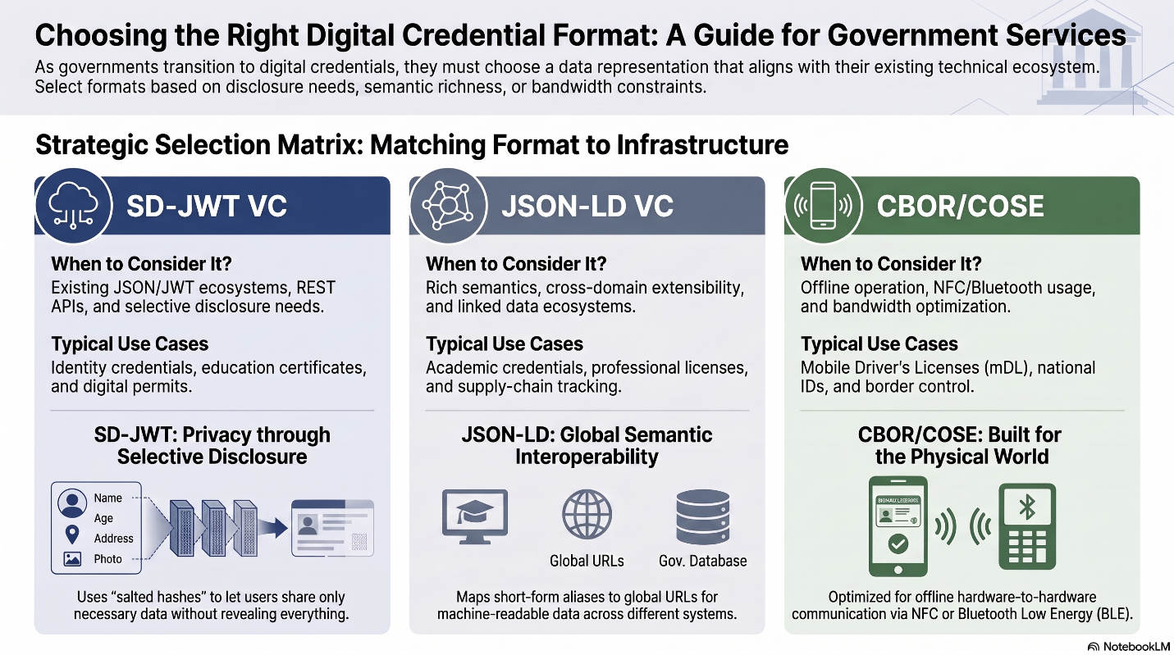
Fig 2: When Should Governments Consider Different Credential Representations?
There is no universally correct credential representation. Mature ecosystems increasingly support multiple representations simultaneously and select the most appropriate representation based on the use case, deployment environment, and interoperability requirements.

2.3 Layer 3: Data Models – How Should Information Be Structured?
After deciding how credentials will be represented and encoded, the next architectural question becomes: What information should a credential contain and how should that information be organized? This is the responsibility of the data model layer.
A Verifiable Credential is more than a collection of claims about an individual or organization. It also contains information about who issued the credential, to whom it was issued, when it was issued, whether it is still valid, and how its authenticity can be verified. A data model provides a common structure for representing all this information in a consistent and interoperable manner. Simply put, if credential representation determines how the data is packaged, the data model determines what the package contains and how its contents are organized.
A credential data model typically defines information relating to the issuer, holder, claims and attributes, metadata, validity periods, status information, supporting evidence, and the relationships between these different elements. Without a common data model, two ecosystems may use the same representation format yet still be unable to consistently interpret and understand each other's credentials.
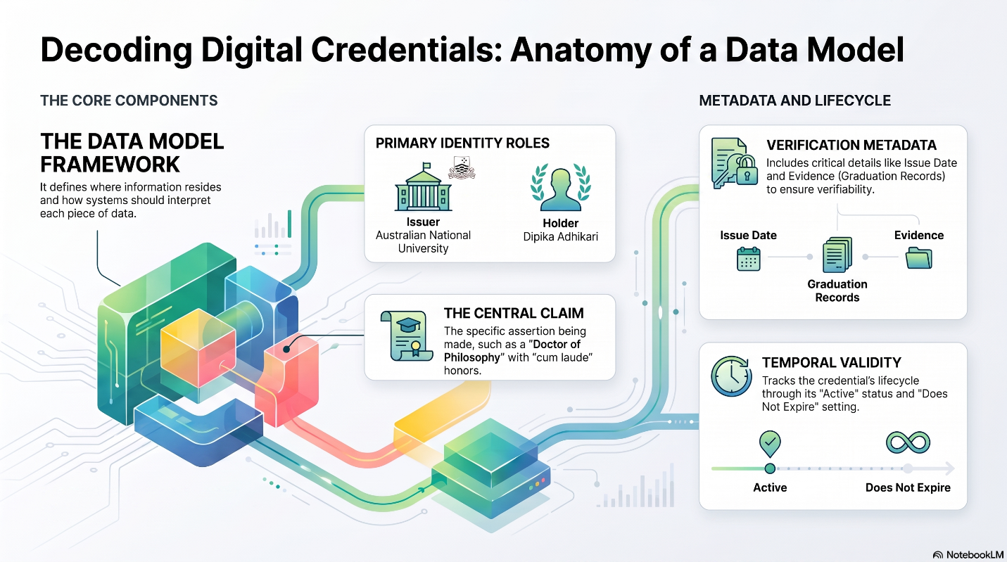
Fig 3: Illustrative Structure of a Verifiable Credential Data Model
Today, two data model approaches are seeing significant adoption: W3C Verifiable Credentials Data Model (W3C VCDM 2.0) and ISO/IEC 18013-5 and 18013-7.
The W3C Verifiable Credentials Data Model (VCDM) 2.0 defines the fundamental building blocks of a verifiable credential, including the issuer, credential subject, credential status, validity periods, evidence, terms of use, and extensibility mechanisms. In essence, VCDM answers the question, "What does a Verifiable Credential look like and what information should it contain?" However, it does not prescribe how credentials are issued, presented, or how trust is established between ecosystem participants, leaving these aspects to complementary standards and protocols. These responsibilities are delegated to other standards such as OpenID4VCI, OpenID4VP, Digital Credentials API, and Trust Registries.
The ISO/IEC 18013 family of standards, particularly ISO/IEC 18013-5 and ISO/IEC 18013-7, defines a data model for mobile documents by specifying the structure of document namespaces, data elements, issuer information, validity information, and device-related metadata. In essence, ISO mdoc answers the question, "What should a mobile document look like and how should its information be organized for secure online and offline presentations?" Unlike W3C VCDM, the ISO standards go beyond the data model and define mechanisms for device engagement, authentication, and presentation over channels such as NFC, Bluetooth, and web-based interactions.

Criteria | W3C VCDM 2.0 | ISO/IEC 18013-5/7
Primary Objective | General-purpose credentials | Mobile documents
Extensibility | Very High | Moderate
Semantic Modelling | Excellent | Moderate
Offline Verification | Depends on representation | Native
Device Authentication | External standards | Built-in
Mobile Documents | Moderate | Excellent
National Identity Use Cases | Excellent | Excellent
Cross-Domain Credentials | Excellent | Moderate
Web Ecosystem Alignment | Excellent | Moderate
NFC and BLE Support | External standards | Native
Table 3: Comparison of Credential Data Models Across Key Architectural Considerations
There is no universally correct data model for digital credentials. The choice of data model should be guided by the type of credentials being issued and the intended deployment scenarios. Governments building highly extensible, cross-sector credential ecosystems may find W3C VCDM 2.0 to be a natural fit, whereas ecosystems focused on mobile documents, device-bound credentials, and offline verification scenarios may benefit more from the capabilities offered by ISO/IEC 18013-5 and ISO/IEC 18013-7.
Increasingly, mature ecosystems are supporting both approaches simultaneously, selecting the most appropriate data model based on the credential type and intended user experience. A data model establishes a common understanding of what information a credential contains and how that information should be interpreted. While credential representations determine how credentials are encoded, data models ensure that credentials can be consistently understood across issuers, wallets, and verifiers.

2.4 Layer 4: Exchange Protocols – How Do Credentials Move?
After deciding how credentials are protected, represented, and structured, governments must determine how credentials move across the ecosystem. This is the responsibility of the exchange layer. A Verifiable Credential ecosystem typically involves three primary participants:
- Issuer – The entity that creates and issues credentials.
- Wallet – The application that stores credentials on behalf of the holder.
- Verifier (Relying Party) – The entity requesting and verifying credential information.
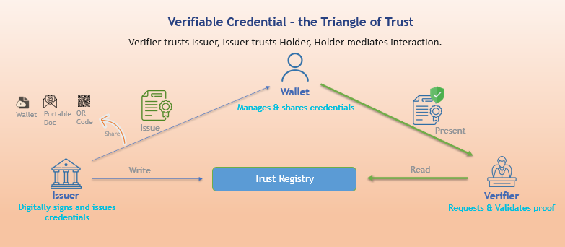
Fig 4: Verifiable credential’s triangle of trust
Exchange protocols define how these participants communicate with one another in a secure and interoperable manner. For domestic ecosystems, exchange protocols primarily influence implementation choices and user experience. However, for cross-border digital identity ecosystems, this layer becomes one of the most critical enablers of interoperability. Regardless of how credentials are protected, represented, or modelled, credentials can only be exchanged across countries if wallets and verifiers agree on a common mechanism for requesting, presenting, and interpreting credential information.
In practice, the exchange layer can be divided into two distinct processes:
- Issuance – Moving credentials from an issuer to a wallet.
- Presentation – Sharing credentials from a wallet to a verifier.
Although both involve the exchange of credentials, they solve fundamentally different problems and therefore have different interoperability requirements.

Credential Issuance – How Do Credentials Reach Wallets?
Credential issuance is the process through which issuer provisions credentials into a holder's wallet. The objective of issuance is to securely transfer credentials from a trusted issuer to an authenticated wallet while preserving the confidentiality and integrity of the credential throughout the exchange process. Examples include governments issuing digital national identity credentials into identity wallets, universities issuing educational credentials into citizen wallets, and banks provisioning financial credentials into financial services wallets.
Several approaches exist for credential issuance, including proprietary APIs, OpenID for Verifiable Credential Issuance (OpenID4VCI), and the W3C Digital Credentials API. While OpenID4VCI and the W3C Digital Credentials API define standardized mechanisms for issuing credentials into wallets, issuance in practice typically occurs between pre-established and trusted participants. An issuer generally knows which wallets it intends to support, and wallets similarly know the issuers with which they integrate.
This pre-established relationship enables issuers and wallets to mutually agree upon authentication mechanisms, API specifications, credential retrieval and lifecycle management processes, storage mechanisms, and even credential rendering guidelines. Consequently, proprietary issuance APIs can often be sufficient and do not necessarily hinder broader ecosystem interoperability.
However, adopting common issuance specifications still provides significant advantages. Standardized protocols reduce the need for bespoke integrations, simplify onboarding of new wallets and issuers, promote portability across ecosystems, and enable a broader market of interoperable wallet solutions. For governments seeking to foster an open and competitive ecosystem with multiple wallet providers and cross-jurisdictional adoption, standards such as OpenID4VCI can significantly reduce integration complexity and improve long-term ecosystem scalability.
Criteria | OpenID4VCI | Proprietary APIs
Standardized | Yes | No
Wallet Interoperability | High | Low
Integration Flexibility | Medium | Very High
Existing Backend Reuse | Moderate | Excellent
Ecosystem Portability | High | Low
Table 4: Comparison of Credential Issuance Approaches
In practice, issuance interoperability is generally less critical because credential issuance typically occurs between pre-established issuers and trusted wallets that can integrate through either standard or proprietary APIs.

Credential Presentation – How Do Wallets Share Credentials?
Credential presentation is the process through which a holder's wallet shares credential information with a verifier, such as a hotel, airport, bank, or government service. Unlike credential issuance, which typically occurs between pre-established and trusted participants, presentation frequently takes place between parties that may have never interacted before and may even belong to different jurisdictions.
Consider the following scenarios:
- An Indian resident checking into a hotel in Thailand;
- A Brazilian citizen opening a bank account in Singapore; or
- European Union resident presenting credentials to a government service abroad.
In each of these cases, the wallet and verifier may have no prior relationship and no pre-existing technical integration. This fundamentally changes the problem from one of simple data exchange to one of interoperable and trusted data exchange.
Presentation therefore requires:
- Common trust mechanisms to establish confidence between participants;
- Standardized request structures for requesting credential information;
- Interoperable credential formats that can be understood across ecosystems; and
- Consistent consent experiences that allow holders to understand and approve what information is being shared.
Without presentation interoperability, every verifier would need to separately integrate with every wallet provider and every national ecosystem. Such an approach is operationally unsustainable and would make large-scale, particularly cross-border, digital identity ecosystems practically impossible.
Consequently, presentation interoperability is arguably the most critical requirement for cross-border Verifiable Credential ecosystems, enabling credentials issued in one jurisdiction to be securely presented and verified in another without requiring bespoke integrations or bilateral technical arrangements.
To enable interoperable credential presentations across wallets and verifiers, several standards have emerged that address different presentation scenarios and deployment requirements. OpenID for Verifiable Presentations (OpenID4VP) defines a protocol for securely requesting and presenting credentials between wallets and verifiers and is increasingly being adopted for web-based and cross-device interactions. The ISO/IEC 18013 family of standards, particularly ISO/IEC 18013-5 and ISO/IEC 18013-7, defines mechanisms for presenting mobile documents in both proximity and online environments, supporting channels such as NFC, Bluetooth, QR codes, and web-based exchanges. The W3C Digital Credentials API (DC API) provides browser and operating system interfaces that enable websites and applications to interact with digital wallets in a standardized manner, simplifying same-device and browser-native credential presentation experiences.
Criteria | OpenID4VP | ISO 18013-5 | ISO 18013-7 | W3C DC API
Web Support | Excellent | Limited | Excellent | Excellent
Cross-Device Presentation | Excellent | Good | Excellent | Excellent
Same-Device Presentation | Excellent | Moderate | Excellent | Excellent
NFC/BLE Support | No | Native | No | Browser Dependent
Browser Integration | Moderate | No | Moderate | Native
Mobile Wallet Integration | Excellent | Excellent | Excellent | Growing
Cross-Border Interoperability | Excellent | Excellent | Excellent | Emerging
Table 5: Comparison of Credential Presentation Standards
The presentation mechanism should be guided by the intended user experience, interaction channels, and interoperability objectives of the ecosystem. Governments building web-based and cross-device credential sharing experiences may find OpenID4VP to be a natural fit, while the W3C Digital Credentials API is particularly attractive for browser-native and same-device interactions. For mobile documents and offline verification scenarios, especially those involving NFC, Bluetooth, or QR code-based exchanges, ISO/IEC 18013-5 and ISO/IEC 18013-7 provide robust and mature mechanisms. In practice, cross-border ecosystems are likely to adopt a combination of these standards, leveraging OpenID4VP and ISO/IEC 18013-7 to enable interoperable credential presentations across wallets, verifiers, and jurisdictions.

2.5 Layer 5: Trust – Why Should Participants Trust Each Other?
After determining how credentials are protected, represented, structured, and exchanged, the final architectural question becomes: Why should ecosystem participants trust one another before sharing sensitive information? A Verifiable Credential ecosystem involves multiple independent participants, including issuers, wallets, and verifiers. Before any credential exchange takes place, each participant needs confidence that the other participants are genuine, authorized, and operating within the boundaries of the ecosystem's trust policies.
For example: A wallet needs assurance that a verifier requesting information is genuine, authorized, and permitted to receive the requested attributes. A verifier needs confidence that the credential originated from a trusted issuer, has not been tampered with, and is being presented by a legitimate wallet. An issuer needs assurance that credentials are being provisioned into trusted wallets and consumed by authorized relying parties. Without these assurances, digital credentials become no different from unverifiable digital documents.
Trust in a Verifiable Credential ecosystem is never one-directional. It is established simultaneously between multiple participants.
Wallet needs to know | Verifier needs to know
Is this verifier genuine? | Did the credential originate from a trusted issuer?
Is this verifier authorized? | Has the credential been tampered with?
Has this verifier been revoked? | Has the credential been revoked or suspended?
What data is this verifier allowed to request? | Is this wallet legitimate and trusted?
Who vouched for this verifier? | Is the credential being presented by the legitimate holder?
Table 6: Bidirectional Trust Requirements in Verifiable Credential Ecosystems
Consider an Indian resident checking into a hotel in Thailand. The hotel generates a QR code requesting identity verification. The resident scans the QR code using a wallet application. At this moment, the wallet must determine: Can I trust this hotel with my identity information? Similarly, the hotel must determine: Can I trust the wallet and the credentials being presented? Neither participant may have interacted before. They may belong to different organizations, operate under different regulatory frameworks, and even reside in different countries.
This is fundamentally a trust problem.
Without a common trust framework, every verifier would need to establish bilateral relationships with every wallet provider and every issuer across the world. Such an approach does not scale and makes global interoperability practically impossible.

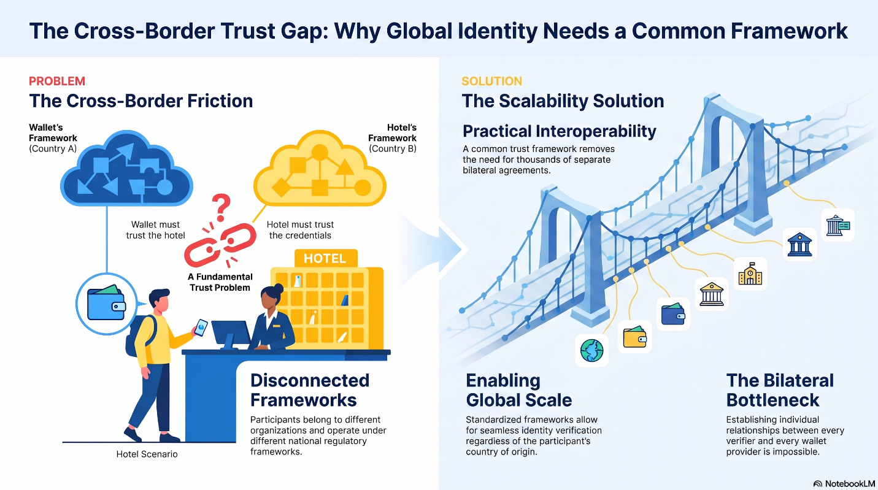
Fig 5: Cross Border Trust Problem-Solution illustration

2.5.1 Trust Establishment Models in Verifiable Credential Ecosystems
As Verifiable Credential ecosystems scale from closed deployments to multi-wallet and cross-border environments, different mechanisms have emerged for establishing trust between issuers, wallets, and verifiers. These mechanisms differ in how trust relationships are established, how trust is evaluated, their operational complexity, and their suitability for various deployment scenarios.
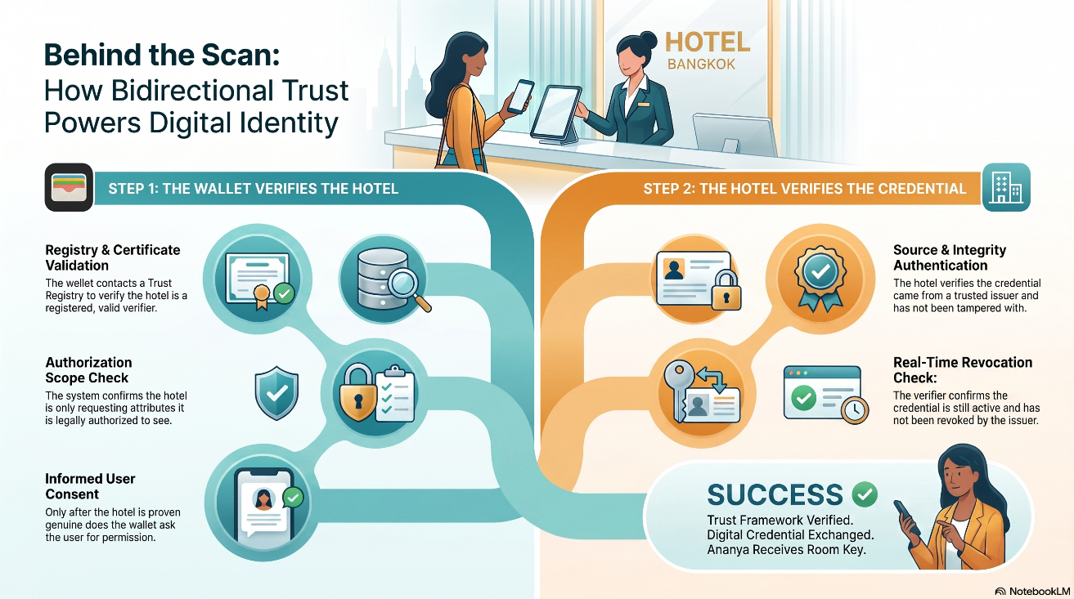
The following sections describe the four commonly adopted trust establishment models.
2.5.1.1 Peer-to-Peer Trust Models
How is trust established?
In a proprietary trust model, trust is established through pre-registered participants and static configurations. Participants exchange certificates or public keys directly during onboarding, and trust relationships are explicitly configured by the ecosystem operator. All trusted entities are known beforehand, and their cryptographic information is statically provisioned into participating systems.
How does trust validation work?
When a verifier requests credential information, the wallet validates the request by comparing the incoming certificates, public keys, or client identifiers against its locally configured trust information. Since all trust information is provisioned during onboarding, trust evaluation is performed entirely locally and does not require calls to any external service or registry.
Standards Alignment
This model closely resembles several established enterprise security patterns, including traditional X.509 Public Key Infrastructure (PKI), Enterprise allow lists, Static client certificate authentication and Mutual TLS (mTLS)
Advantages and Limitations
Direct, peer-to-peer trust architectures offer a highly secure foundation for decentralized ecosystems, prioritizing data privacy and operational independence. By eliminating the need for external lookups, this model ensures that verification remains strictly confidential while enabling seamless offline functionality. Furthermore, its simple implementation relies on minimal infrastructure, significantly reducing operational dependencies and overhead from the start.
However, as the network grows, these benefits are countered by significant scaling bottlenecks and administrative complexities. Expanding the ecosystem demands manual participant onboarding and complex certificate management, which rapidly compromises efficiency. Without a centralized or federated directory, discovering new participants becomes incredibly difficult, rendering this approach largely unsuitable for dynamic, multi-jurisdiction, or cross-border deployments.
Suitable Deployment Scenarios
Proprietary trust frameworks excel in tightly regulated settings where security and absolute governance override the need for massive scalability. They are ideally optimized for closed ecosystems, controlled enterprise environments, and single-wallet deployments where the issuing and verifying authorities operate under a unified umbrella. Because they thrive on predictability, these models are also perfect for initial ecosystem launches, allowing a limited number of participants to establish a secure baseline before facing the complexities of broader interoperability.
2.5.1.2 Centralized Trust Models

How Trust is Established
A centralized trust registry establishes trust by serving as the definitive, authoritative repository for all approved ecosystem participants. Under this model, a central governing entity manages the core onboarding process, maintaining up-to-date trust lists, cryptographic certificates, participant metadata, and real-time revocation information. By consolidating this data, the registry operates as the single, indisputable source of truth for all identity and verification decisions across the network.

How Trust Validation Works
To validate interactions, wallets periodically synchronize with the central registry to download and cache critical data, including Lists of Trusted Elements (LoTE), Certificate Revocation Lists (CRL), and detailed participant metadata. When a verifier requests credential information, the wallet performs a comprehensive trust evaluation locally by checking if the verifier is registered, active, and holding a valid, unrevoked certificate authorized for that specific attribute request. Because this infrastructure allows all necessary validation data to be stored directly on the device, trust evaluations can be executed seamlessly even when the wallet is entirely offline.

Standards Alignment
This framework aligns closely with globally recognized trust infrastructures and mature identity standards. It directly maps to ETSI TS 119 612 and eIDAS Trusted Lists, which govern European digital identity, as well as the ICAO Public Key Directory (PKD) used for electronic travel documents. Additionally, it integrates smoothly with the OpenID4VP Centralized Trust Profile and traditional X.509 Public Key Infrastructure (PKI) ecosystems, ensuring broad interoperability across legacy and modern digital wallet architectures.

Advantages and Limitations
Centralized models offer significant administrative benefits, providing streamlined governance, robust certificate revocation capabilities, and a singular source of truth that makes them exceptionally well-suited for large-scale national deployments. Furthermore, because data is cached locally, it provides excellent support for offline trust evaluation without compromising security. However, these advantages come with specific operational trade-offs, including the necessity of periodic synchronization to keep local trust lists current and the ongoing overhead of managing registry updates and certificate rotations. Additionally, participant discovery remains largely static, offering limited support for the real-time onboarding and immediate recognition of new participants.

Suitable Deployment Scenarios
Given their structured governance, centralized trust registries are ideal for highly regulated, large-scale public sector implementations. They are perfectly optimized for national identity ecosystems, mobile document platforms, and government-controlled trust environments. This makes them the standard choice for secure, state-backed digital public infrastructure, such as national identity networks, official document repositories, and sovereign government wallet ecosystems.
2.5.1.3 Federated Trust Frameworks
How Trust is Established
Federated trust frameworks establish trust dynamically through signed metadata and cryptographic trust chains rather than relying on static, periodically downloaded lists. In this architecture, a designated Trust Anchor publishes overarching federation metadata, while each participating entity exposes standardized federation endpoints. Trust relationships are built on the fly through signed entity statements, allowing participants to dynamically discover, verify, and authorize one another without a rigid, central bottleneck.
How Trust Validation Works
When a verifier requests credential information, the wallet dynamically retrieves and validates a real-time chain of evidence. This includes evaluating entity statements, trust chains, trust marks, public signing keys, authoritative hints, and specific policy metadata. Because these trust decisions are established at runtime, the validation process is generally performed online, allowing secure interactions to occur seamlessly between participants who may have never previously interacted.
Standards Alignment
This model is natively supported by emerging international standards and modern digital identity deployments designed for global scale. It aligns directly with OpenID Federation 1.0, OpenID4VP, and OpenID4VCI specifications. Furthermore, it serves as a core architectural pattern for the European Digital Identity Wallet Architecture Reference Framework (EUDI ARF) and the Swiss E-ID ecosystem, proving its compliance with strict, cutting-edge sovereign identity requirements.
Advantages and Limitations
The primary advantage of federated frameworks lies in their exceptional scalability and fluid dynamics, offering real-time trust evaluation, rich metadata exchange, and immediate onboarding of new participants. This makes them highly effective at facilitating cross-border interoperability and enabling secure transactions between previously unknown entities. However, these capabilities introduce distinct limitations, including significantly increased implementation complexity and a steeper operational learning curve. Additionally, because trust is calculated at runtime across distributed networks, the system requires a high level of governance effort and is fundamentally dependent on stable online connectivity.
Suitable Deployment Scenarios
Federated trust frameworks are uniquely engineered for complex, multi-wallet and multi-jurisdiction ecosystems where rigid centralized control is impractical. They are the ideal choice for large, decentralized networks, international trust frameworks, and cross-border interoperability deployments where diverse legal and technical boundaries must seamlessly interconnect.
2.5.1.4 Issuer-Signed Short-Lived Authentication Certificates
How Trust is Established
In this framework, the credential issuer acts as the primary, centralized trust anchor. During the initial onboarding phase, the issuer directly verifies the identity of the verifier and provisions them with a long-lived X.509 certificate. At runtime, rather than using this long-lived credential directly for transactions, the verifier periodically exchanges it with the issuer to obtain a short-lived authentication certificate, which it then presents to the digital wallet when requesting credential data.
How Trust Validation Works
The wallet processes and validates the transaction locally by evaluating a series of cryptographic artifacts. It directly verifies the issuer’s signature, the certificate's validity and issuance time, the request's cryptographic signature, and the explicit expiration window of the short-lived authentication certificate. Because the trust decision relies entirely on these locally verifiable elements, the wallet requires zero external service calls or online connectivity during transaction processing.
Standards Alignment
This approach shares strong architectural parallels with several established enterprise security architectures and token-based delegation systems. It heavily leverages traditional X.509 Public Key Infrastructure (PKI) and Mutual TLS (mTLS) for secure channel establishment, while mimicking the temporary, time-bound access patterns found in OAuth Client Assertions, SPIFFE/SPIRE workload identities, Kerberos Tickets, and AWS Security Token Service (STS) temporary credentials.
Advantages and Limitations
The primary advantage of this model is its excellent support for offline verification and exceptionally fast transaction processing, combined with strong privacy guarantees since no runtime tracking occurs. Furthermore, because the authentication certificates are short-lived and expire rapidly by design, the operational burden of managing complex certificate revocation lists is virtually eliminated. Conversely, the model creates a significant limitation by turning the issuer into a permanent, central operational dependency that must constantly remain available to issue temporary tokens. This requirement introduces distinct scaling challenges as the number of verifiers grows, and offers limited federation capabilities, making it poorly suited for large-scale, cross-border deployments.
Suitable Deployment Scenarios
Issuer-signed short-lived certificate models are highly effective for constrained, high-security environments where the issuer maintains a direct relationship with all consuming parties. They are particularly suitable for closed enterprise ecosystems, single-wallet rollouts, and government-controlled trust environments. This makes them an ideal fit for localized, low-scale ecosystems or specialized, sovereign single-issuer deployments.
Trust Model | Trust Anchor | Trust Validation | Offline Support | Cross-Border Suitability | Complexity
Proprietary | Ecosystem Operator | Static certificates | Excellent | Limited | Low
Centralized Trust Registry | Trust Registry | LoTE + CRL + Metadata | Excellent | Good | Medium
Federated Trust Framework | Federation Trust Anchor | Entity Statements + Trust Chains | Moderate | Excellent | High
Short-Lived Certificates | Issuer | Authentication Certificates | Excellent | Moderate | Medium
Table 7: Comparison of Trust Establishment Approaches in Verifiable Credential Ecosystems
As digital identity ecosystems evolve from single-wallet national deployments to multi-wallet and cross-border ecosystems, trust establishment mechanisms must progressively evolve from static configurations towards dynamic and federated trust frameworks that can securely accommodate previously unknown participants across jurisdictions.

Final Thought
Verifiable Credentials should not be viewed as a single standard or technology choice. Rather, they represent an interoperable technology stack comprising multiple architectural layers, including cryptography, credential representations, data models, exchange protocols, and trust frameworks. Each layer addresses a distinct problem and offers multiple standards and implementation approaches, each optimized for different policy objectives and deployment scenarios.
The objective for governments, therefore, is not to identify a single "winning" standard. Instead, it is to thoughtfully assemble the right combination of technologies that aligns with their requirements for privacy, interoperability, scalability, offline capabilities, and cross-border data exchange.
Successful Verifiable Credential ecosystems are not built by adopting a single specification. They are built by making a series of deliberate architectural decisions across all five layers of the stack and selecting the combination of standards that best aligns with national policy objectives and user needs.

